Module 2: Git Assignment – 1
1. Based on what you have learnt in the class, do the following steps:
a. Create a new folder
b. Put the following files in the folder
1. Code.txt
2. Log.txt
3. Output.txt
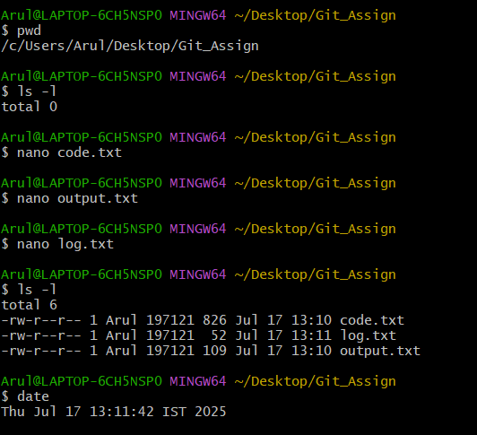
c. Stage the Code.txt and Output.txt files
d. Commit them
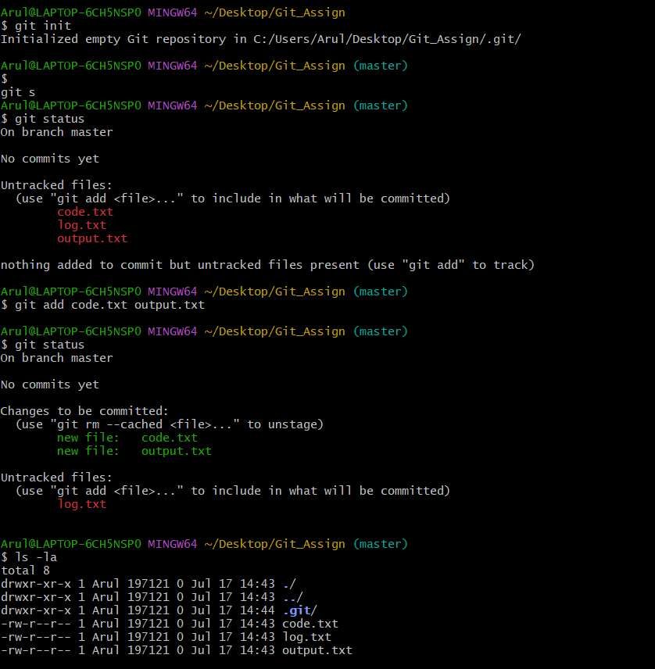
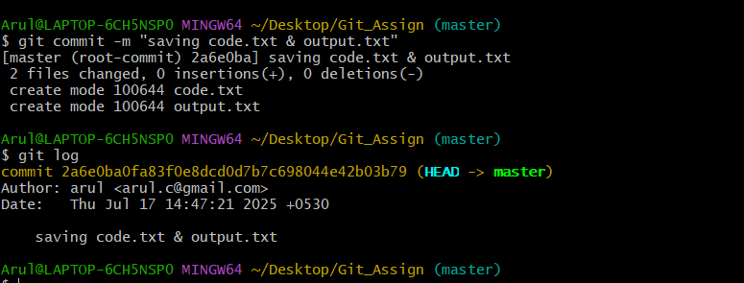
e. And finally push them to GitHub

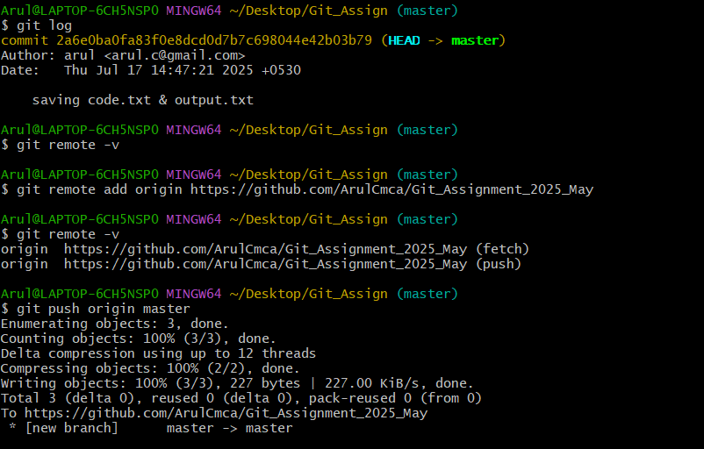

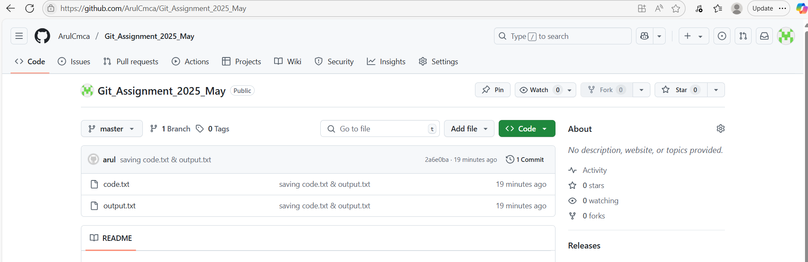

Module 2: Git Assignment – 2
Tasks To Be Performed:
1. Create a Git working directory with feature1.txt and feature2.txt in the master branch

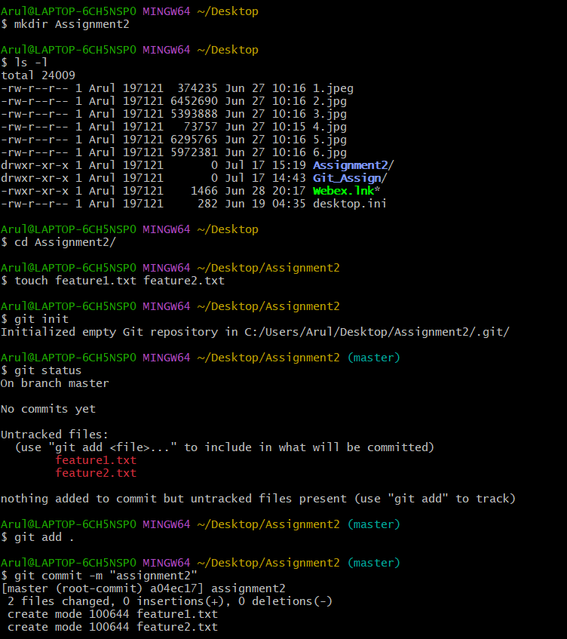

2. Create 3 branches develop, feature1 and feature2

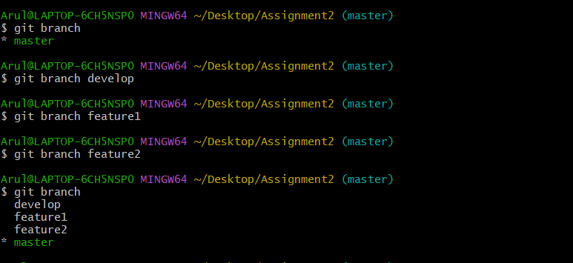
3. In develop branch create develop.txt, do not stage or commit it
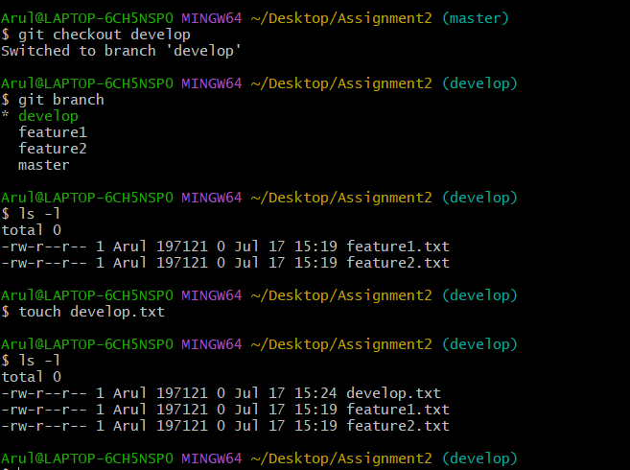
4. Stash this file and check out to feature1 branch
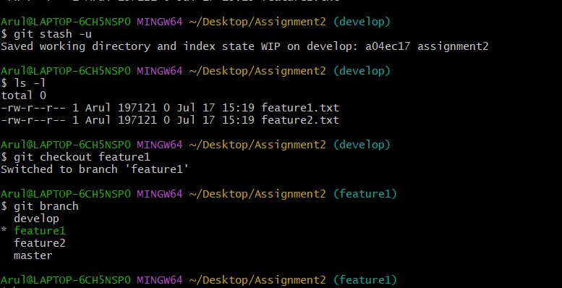
5. Create new.txt file in feature1 branch, stage and commit this file
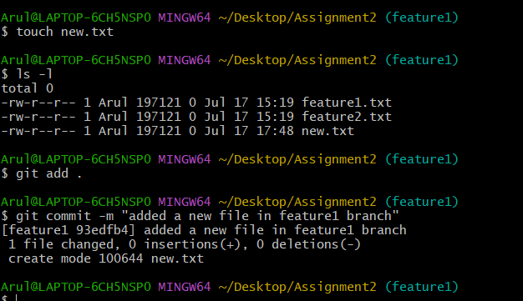
6. Checkout to develop, unstash this file and commit
7. Please submit all the Git commands used to do the

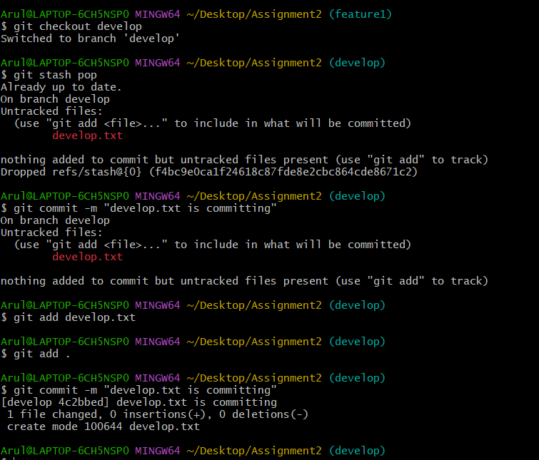

Git Assignment – 3:

Tasks To Be Performed:
1. Create a Git working directory, with the following branches:
● Develop
● F1
● f2
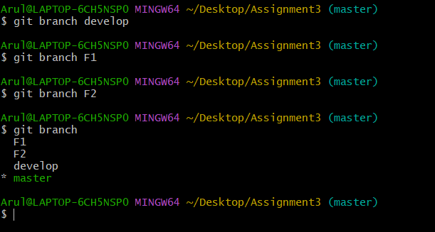
2. In the master branch, commit main.txt file
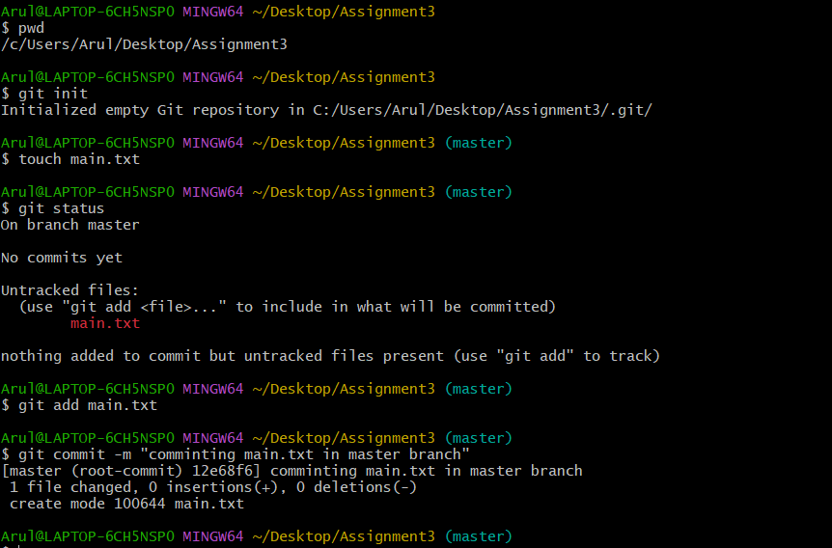
3. Put develop.txt in develop branch, f1.txt and f2.txt in f1 and f2 respectively

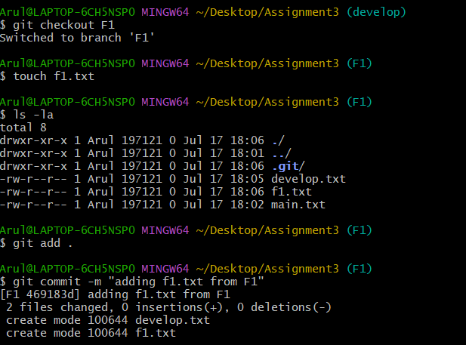

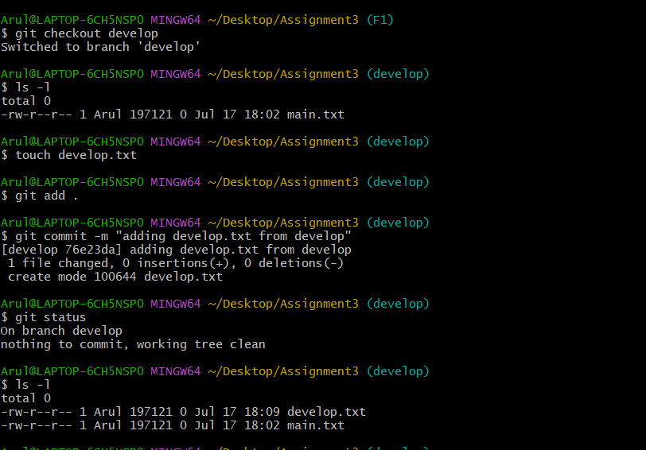

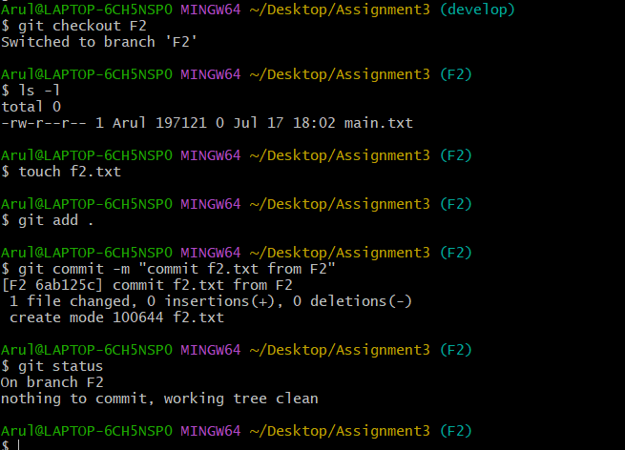

4. Push all these branches to GitHub

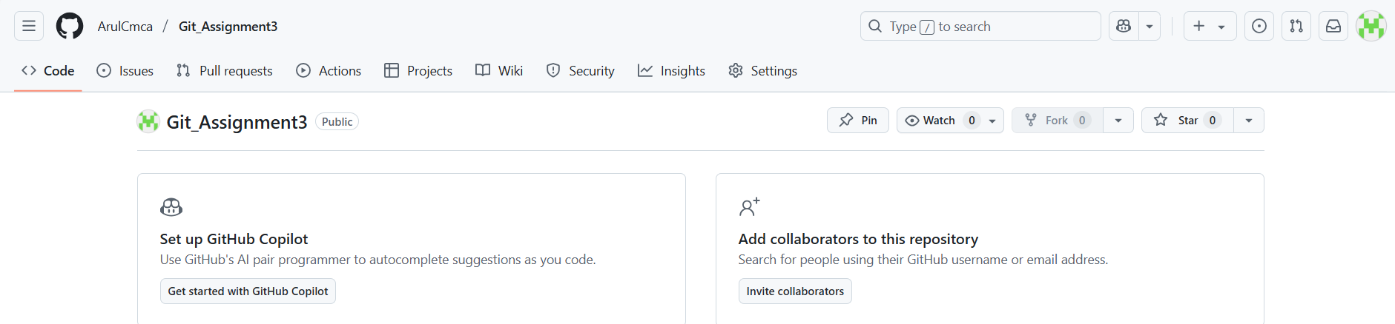

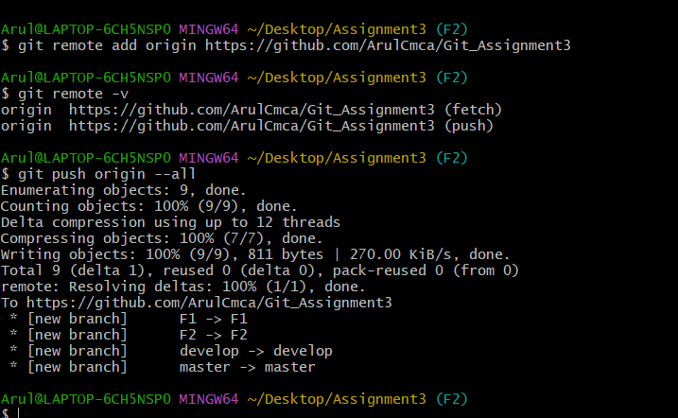

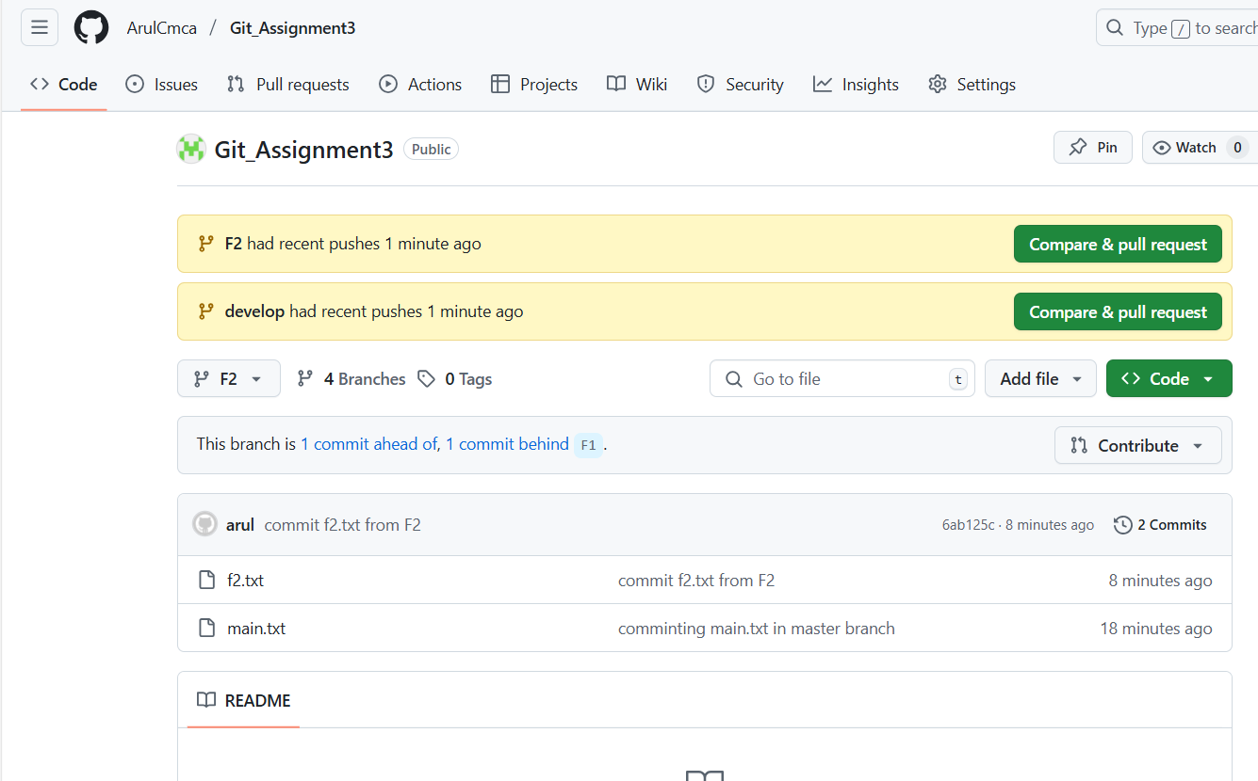

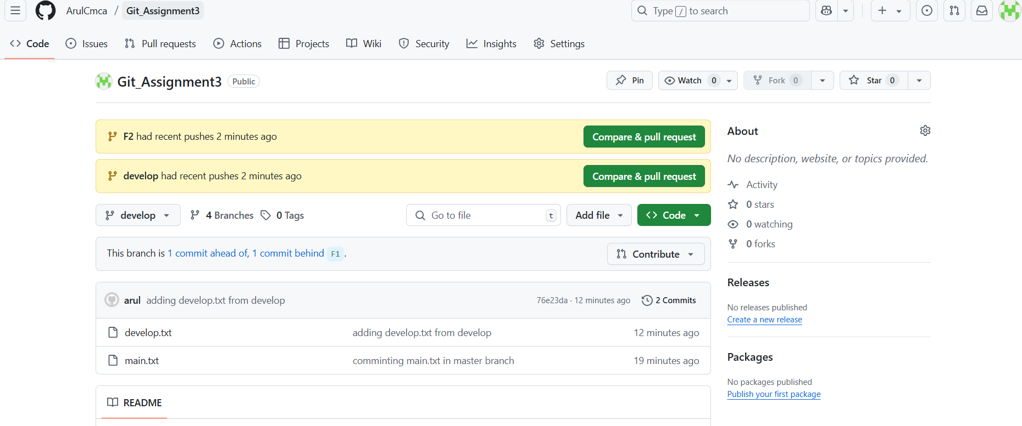

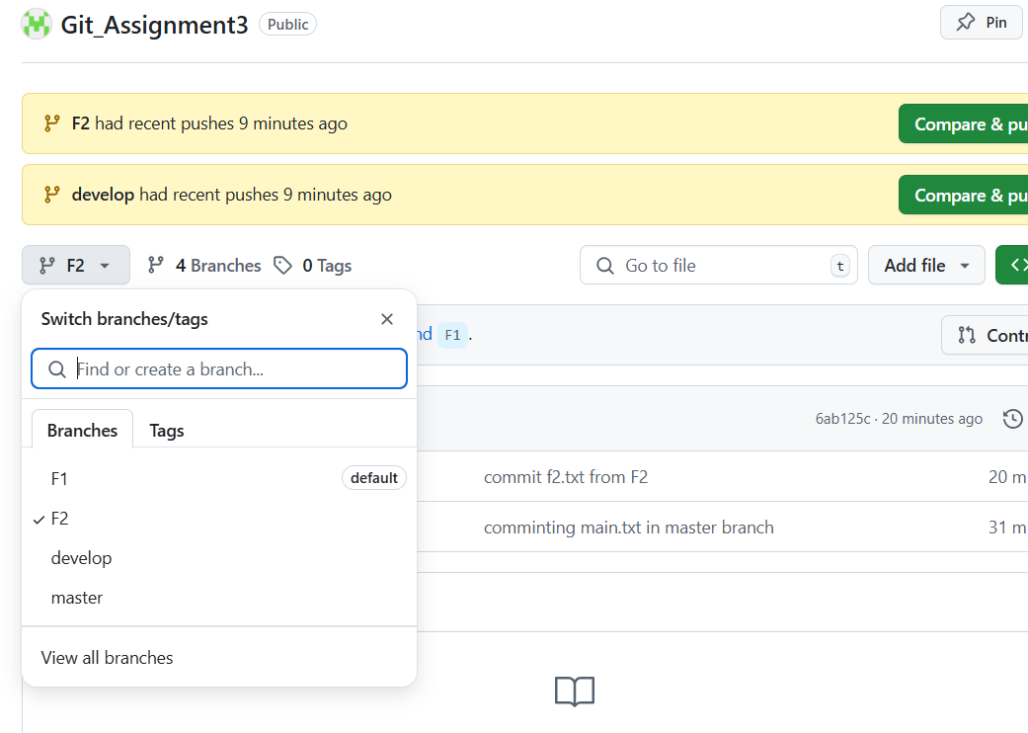

5. On local delete f2 branch
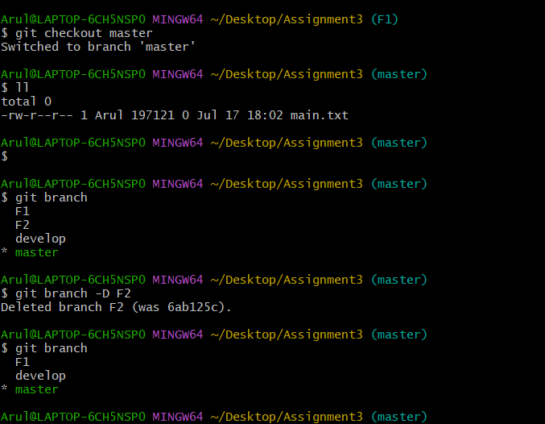

6. Delete the same branch on GitHub as well

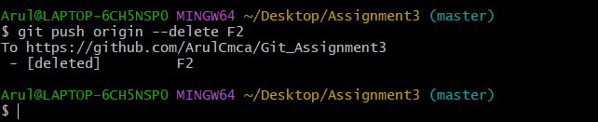
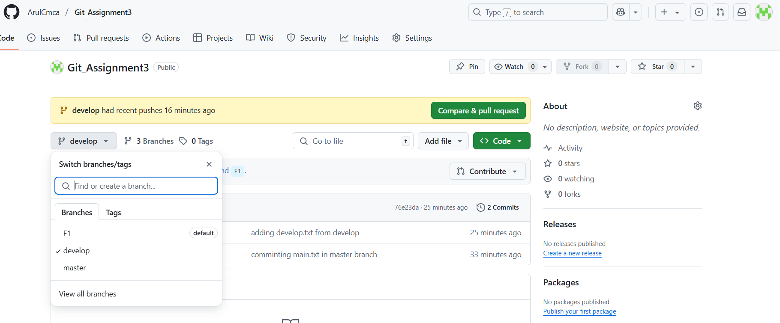

Module 2: Git Assignment – 4

Tasks To Be Performed:
1. Put master.txt on master branch, stage and commit

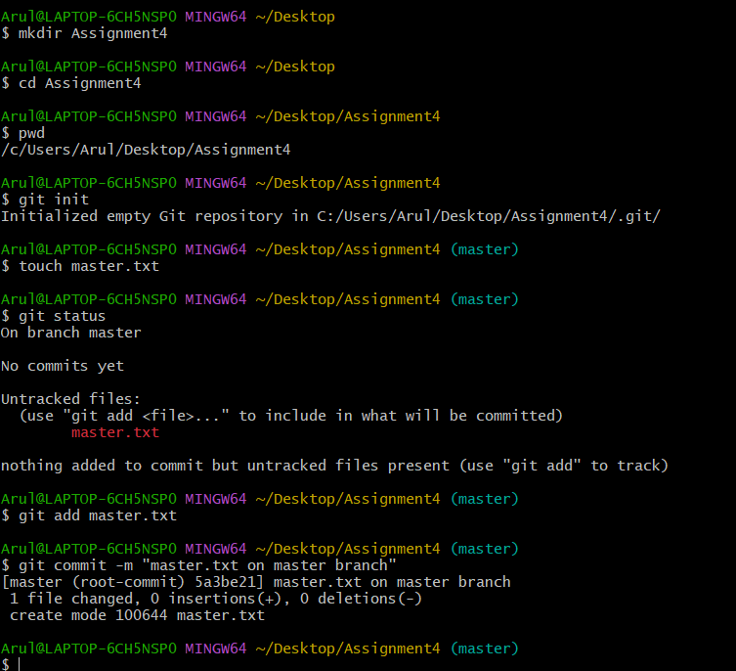
2. Create 3 branches: public 1, public 2 and private

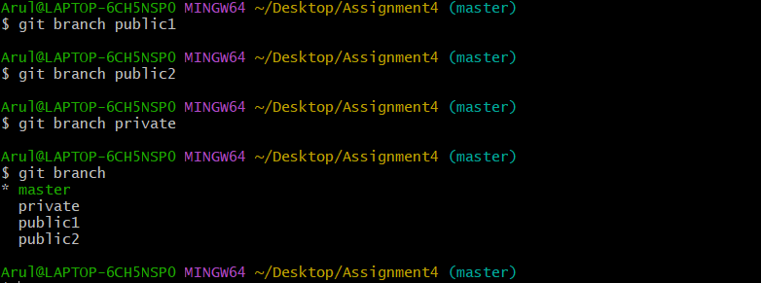

3. Put public1.txt on public 1 branch, stage and commit

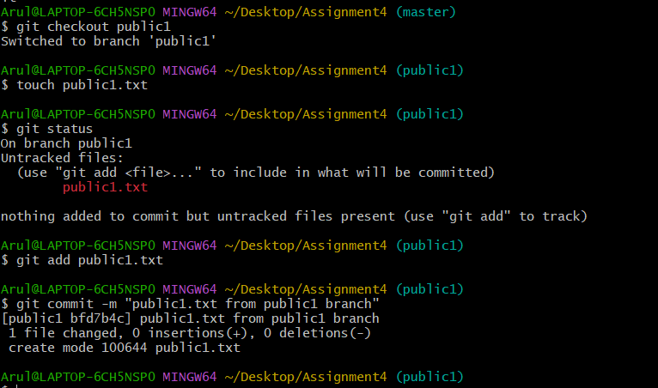
4. Merge public 1 on master branch
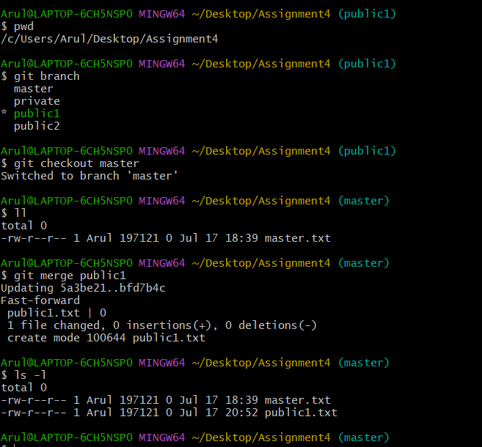

5. Merge public 2 on master branch
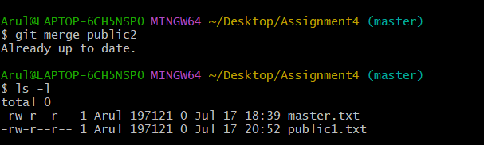
6. Edit master.txt on private branch, stage and commit
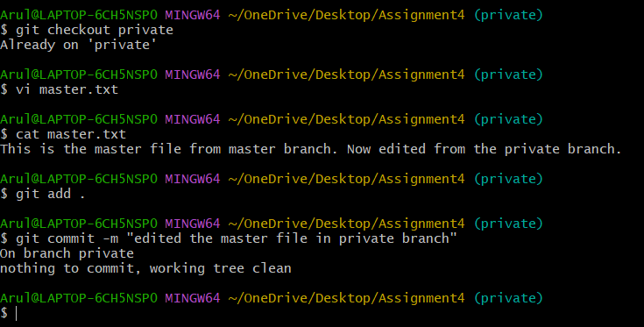
7. Now update branch public 1 and public 2 with new master code in private
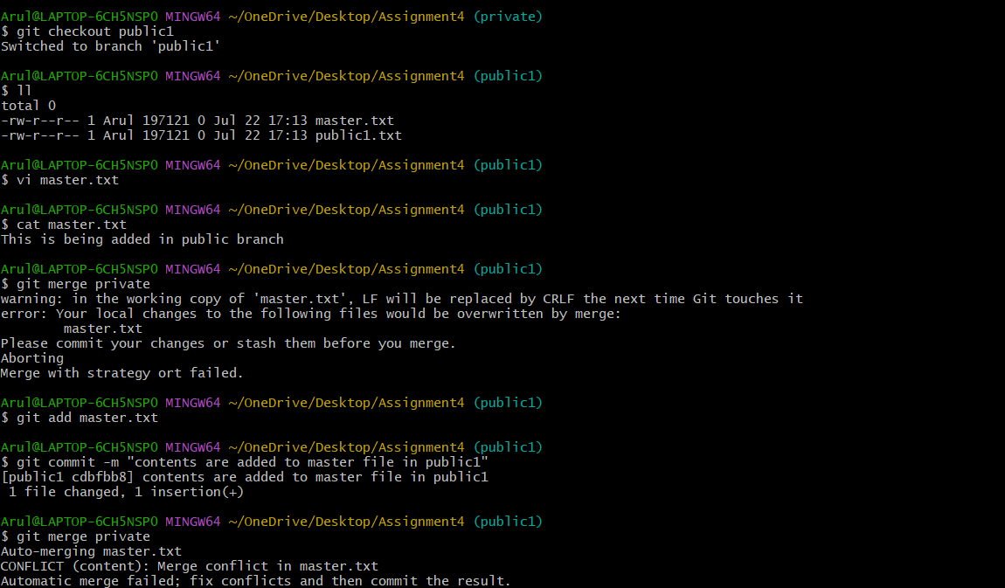
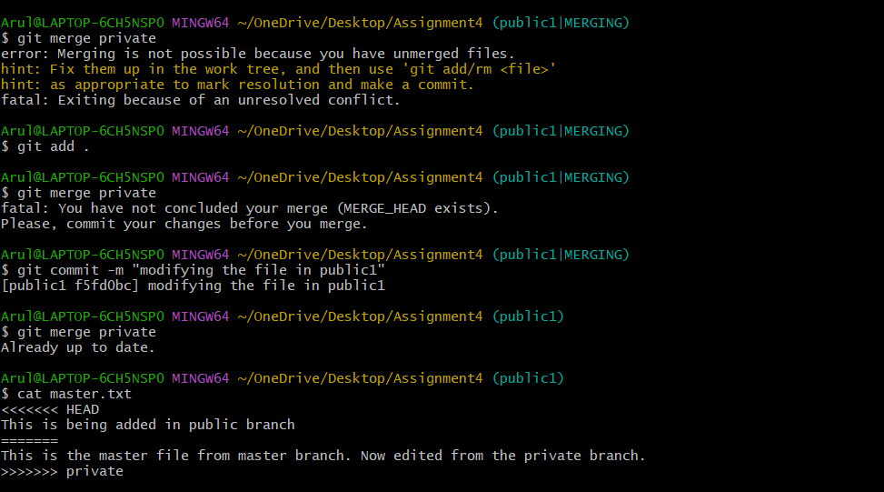
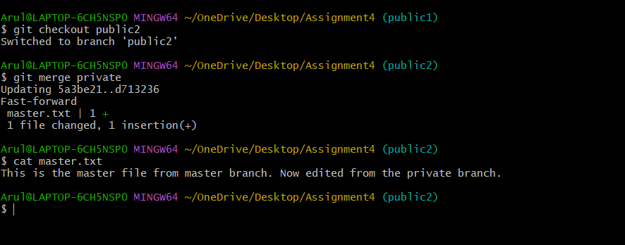
8. Also update new master code on master
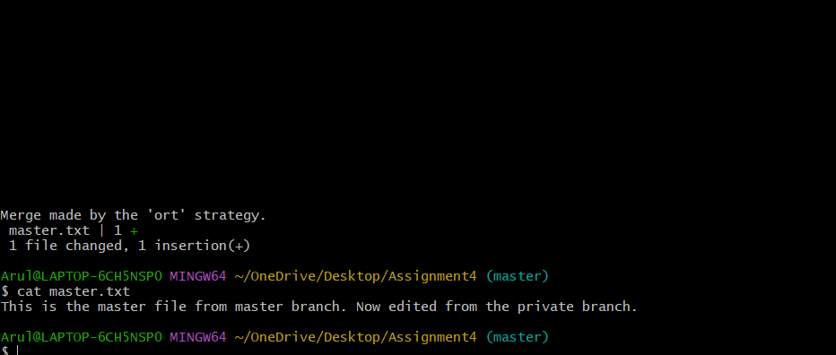
9. Finally update all the code on the private branch
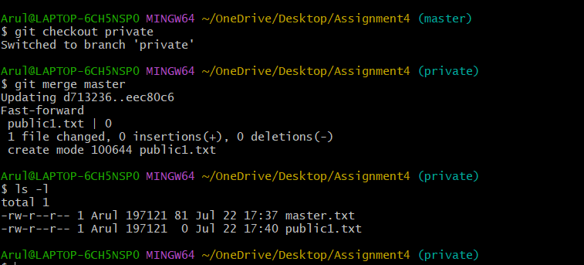

Module 2: Git Assignment – 5
1. Create a Git Flow workflow architecture on Git
2. Create all the required branches
3. Starting from the feature branch, push the branch to the master, following the architecture
4. Push a urgent.txt on master using hotfix
